**AST Design 2.0**

specification -> definition { definition }

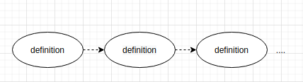

(definition子树至少出现一次)

definiton -> type_decl“;”| module “;”

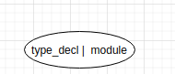

module -> “module”ID “{” definition { definition } “}”

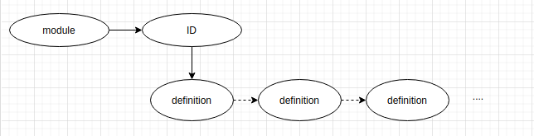

(definition子树至少出现一次)

type_decl -> struct_type | “struct” ID

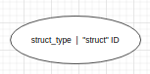

struct_type->“struct” ID “{” member_list “}”

member_list-> { type_spec declarators “;” }

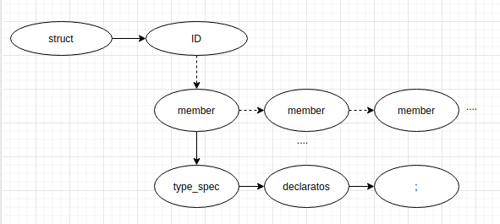

(虚线表示可以有0个member子元素.将type declaratos ;子树用member概括.)

(如果memberlist中没有一个member元素,则在子树位置输出empty,这样可以区别struct m和struct m{}的区别.)

type_spec -> scoped_name | base_type_spec | struct_type

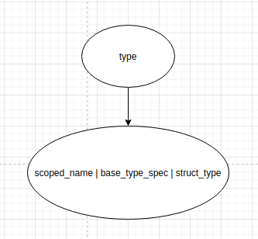

该文法规则需要将父节点的语法规则保留为type关键字.该节点子树将直接为变量类型.

scoped_name -> [“::”] ID {“::” ID }

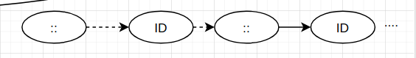

base_type_spec->floating_pt_type|integer_type|“char”|“string”| “boolean”

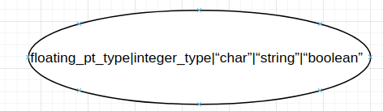

floating_pt_type -> “float” | “double” | “long double”

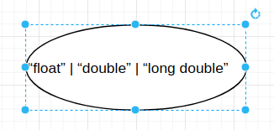

integer_type -> signed_int | unsigned_int

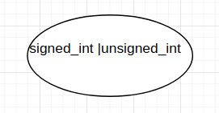

signed_int->(“short”|“int16”) |(“long”|“int32”) |(“long” “long”|“int64”) |“int8”

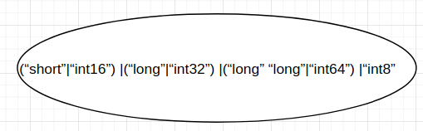

unsigned_int -> (“unsigned”“short”| “uint16”) | (“unsigned”“long”| “uint32”) | (“unsigned” “long” “long” | “uint64”) | “uint8”

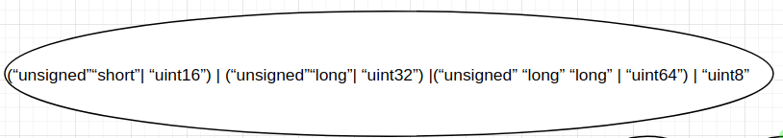

declarators -> declarator {“,” declarator }

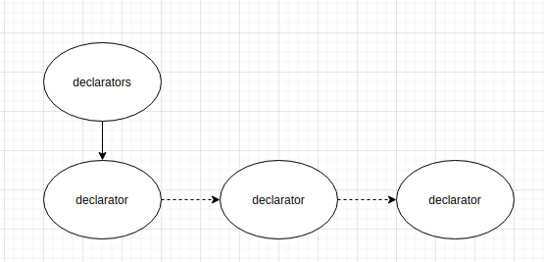

这个文法规则需要保留父节点的关键字declarators.该子树将直接为变量名称.

declarator -> simple_declarator | array_declarator

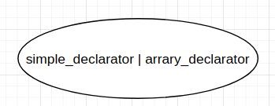

simple_declarator -> ID [“=” or_expr]

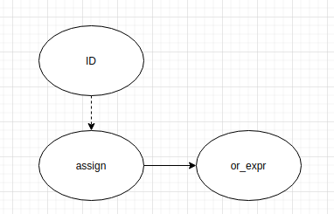

array_declarator -> ID “[” or_expr “]” [“=” exp_list ]

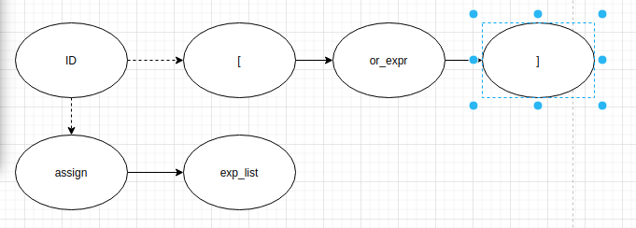

这里的[]代表数组大小,所以没有省略

exp_list -> “[” or_expr { “,”or_expr } “]”

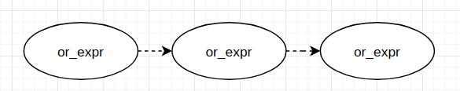

or_expr -> xor_expr {“|” xor_expr }

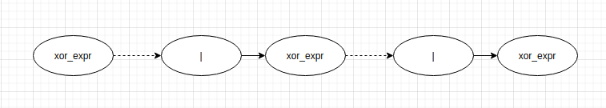

xor_expr -> and_expr {“^” and_expr }

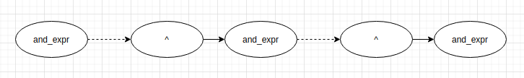

and_expr -> shift_expr {“&”shift_expr }

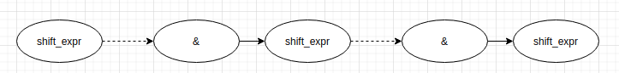

shift_expr -> add_expr { (“>>” | “<<”) add_expr }

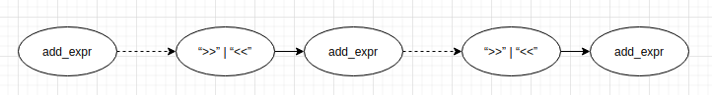

add_expr -> mult_expr { (“+” | “-”) mult_expr }

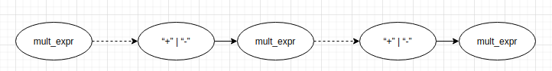

mult_expr -> unary_expr { (“*” |“/”|“%”) unary_expr }

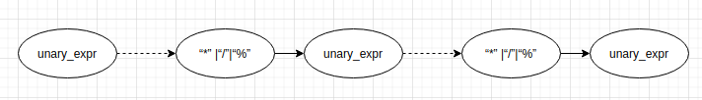

unary_expr -> [“-”| “+” | “~”] literal

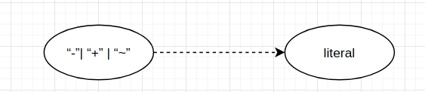

literal -> INTEGER | FLOATING_PT | CHAR | STRING | BOOLEAN

